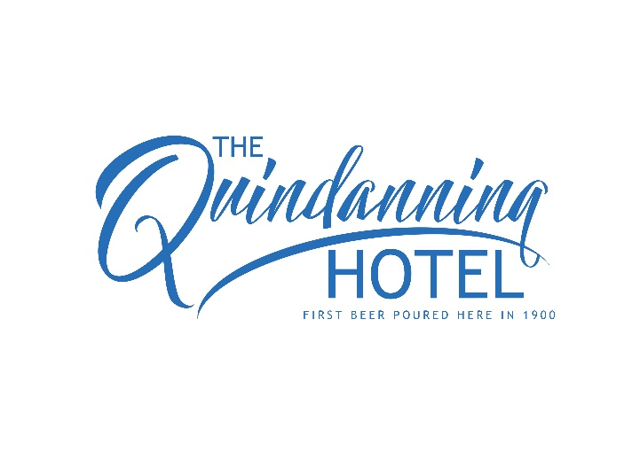
OFFICE USE ONLY
EFT / CASH / INVOICE
Signed:
BREAKFAST ORDER FORM
NAME: _____________________________________________________
ROOM No.: _________
TIME TO EAT: ______________ (Note: before 8am incurs a $5 surcharge)
DATE OF BREAKFAST: _______________________
OPTIONS
2 eggs on inch-sliced fresh toasted bread……………………..$7.50
Add:
2 x Bacon……………..…$3.50
Chorizo……………….…..$3.50
Garlic Mushroom…..…$2.00
Fresh Tomato………..…$2.00
Hash Brown……..………$1.50
Baked Beans…………….$2.00
Fresh Spinach…….…….$2.00
Smashed Avocado……$3.00

Pancakes 3-Ways (2 pancakes per serve):
Nanna’s Way, with fresh lemon & sugar…………………………….$10.00
Fruitilicious, with fruit coulis & banana………………………………$11.00
ADD: Ice-cream or yoghurt (if available) .….$1.00
Canadian Way, with Banana, Bacon & Maple Syrup……….…$14.00

Slow cooked Porridge, served with grated apple, fruit coulis & Greek yoghurt….$11.50

